UNITED STATES
SECURITIES AND EXCHANGE COMMISSION
Washington, D.C. 20549

SCHEDULE 14A
Proxy Statement Pursuant to Section 14(a) of the
Securities Exchange Act of 1934
(Amendment No. )

Filed by the Registrant ☒
Filed by a Party other than the Registrant ☐
Check the appropriate box:

☐ | Preliminary Proxy Statement

☐ | Confidential, for Use of the Commission Only (as permitted by Rule 14a-6(e)(2))

☐ | Definitive Proxy Statement

☒ | Definitive Additional Materials

☐ | Soliciting Material Pursuant to § 240.14a-12

Smartbird, Inc.
(Exact name of registrant as specified in its charter)

(Name of Person(s) Filing Proxy Statement if other than the Registrant)
Payment of Filing Fee (Check all boxes that apply):

☒ | No fee required.

☐ | Fee paid previously with preliminary materials

☐ | Fee computed on table in exhibit required by Item 25(b) per Exchange Act Rules 14a-6(i)(1) and 0-11

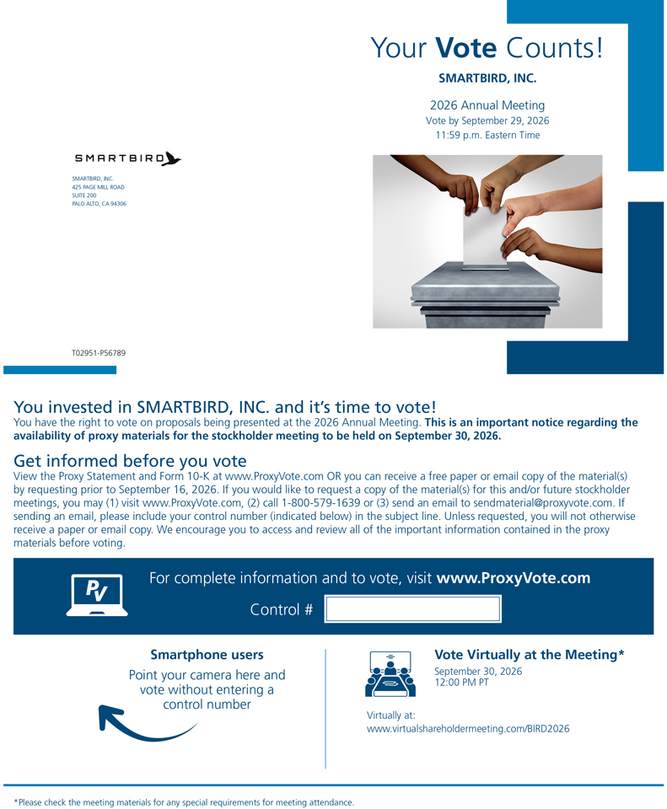
Your Vote Counts!
SMARTBIRD, INC.
2026 Annual Meeting
Vote by September 29, 2026
11:59 p.m. Eastern Time
SMARTBIRD, INC.
425 PAGE MILL ROAD
SUITE 200
PALO ALTO, CA 94306
T02951-P56789
You invested in SMARTBIRD, INC. and it’s time to vote!
You have the right to vote on proposals being presented at the 2026 Annual Meeting. This is an important notice regarding the availability of proxy materials for the stockholder meeting to be held on September 30, 2026.
Get informed before you vote
View the Proxy Statement and Form 10-K at www.ProxyVote.com OR you can receive a free paper or email copy of the material(s) by requesting prior to September 16, 2026. If you would like to request a copy of the material(s) for this and/or future stockholder meetings, you may (1) visit www.ProxyVote.com, (2) call 1-800-579-1639 or (3) send an email to sendmaterial@proxyvote.com. If sending an email, please include your control number (indicated below) in the subject line. Unless requested, you will not otherwise receive a paper or email copy. We encourage you to access and review all of the important information contained in the proxy materials before voting.
For complete information and to vote, visit www.ProxyVote.com
Control #
Smartphone users
Point your camera here and vote without entering a control number
Vote Virtually at the Meeting*
September 30, 2026
12:00 PM PT
Virtually at:
www.virtualshareholdermeeting.com/BIRD2026
*Please check the meeting materials for any special requirements for meeting attendance.
Vote at www.ProxyVote.com
THIS IS NOT A VOTABLE BALLOT

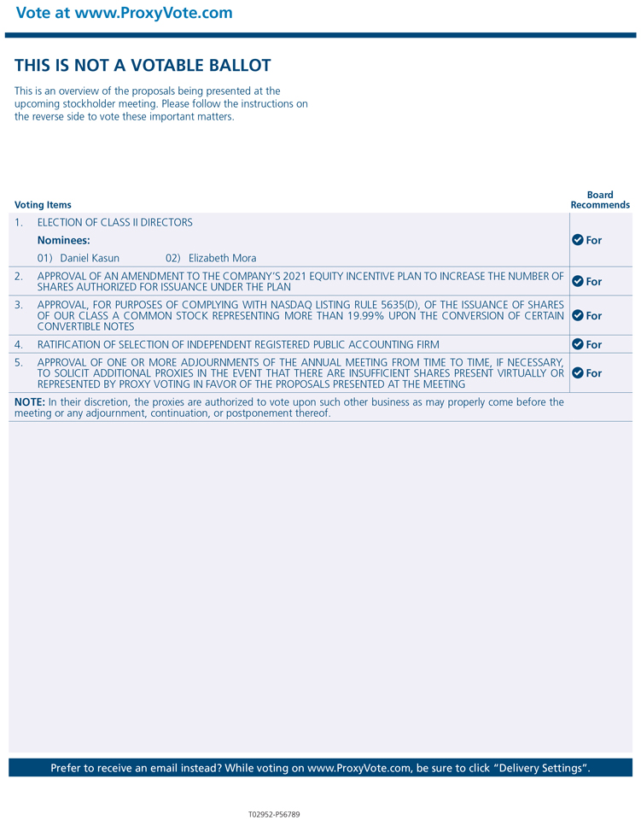
This is an overview of the proposals being presented at the upcoming stockholder meeting. Please follow the instructions on the reverse side to vote these important matters.
Board Recommends
Voting Items
1. ELECTION OF CLASS II DIRECTORS For
Nominees:
01) Daniel Kasun
02) Elizabeth Mora
2. APPROVAL OF AN AMENDMENT TO THE COMPANY’S 2021 EQUITY INCENTIVE PLAN TO INCREASE THE NUMBER OF SHARES AUTHORIZED FOR ISSUANCE UNDER THE PLAN For
3. APPROVAL, FOR PURPOSES OF COMPLYING WITH NASDAQ LISTING RULE 5635(D), OF THE ISSUANCE OF SHARES OF OUR CLASS A COMMON STOCK REPRESENTING MORE THAN 19.99% UPON THE CONVERSION OF CERTAIN CONVERTIBLE NOTES For
4. RATIFICATION OF SELECTION OF INDEPENDENT REGISTERED PUBLIC ACCOUNTING FIRM For
5. APPROVAL OF ONE OR MORE ADJOURNMENTS OF THE ANNUAL MEETING FROM TIME TO TIME, IF NECESSARY, TO SOLICIT ADDITIONAL PROXIES IN THE EVENT THAT THERE ARE INSUFFICIENT SHARES PRESENT VIRTUALLY OR REPRESENTED BY PROXY VOTING IN FAVOR OF THE PROPOSALS PRESENTED AT THE MEETING For
NOTE: In their discretion, the proxies are authorized to vote upon such other business as may properly come before the meeting or any adjournment, continuation, or postponement thereof.

